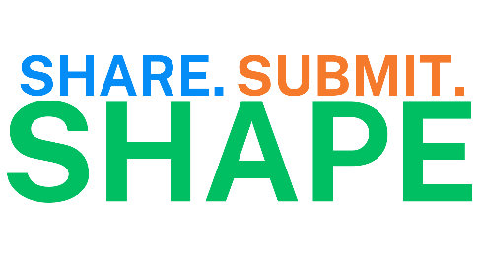
Community Partner – Client Email Template Version A

Client,
Will you share what impacts your health to help identify the health needs of our community and shape a plan to address them?
Community participation is critical to developing a plan to improve health and quality of life in Winnebago County.
Please Click Here and take 10 minutes to submit your experiences before March 8, 2024.
All Winnebago County residents that are 18 and older can submit their experiences. Your individual responses are confidential and participation is voluntary.

Thank you for helping shape the health of Winnebago County!
(NAME OF YOUR ORGANIZATION)

Community Partner – Client Email Template Version B
Client,
We know you care about our community and want to ensure you have the opportunity to share what impacts your health in Winnebago County.
All Winnebago County residents that are 18 and up can submit their experiences to the Winnebago County Health Department. Your individual responses are confidential and participation is voluntary.

Please Click Here and take 10 minutes to submit your experiences before March 8, 2024.

The Winnebago County Health Department will work with residents and community partners including (Name of Your Organization) to address the health priorities identified.

Sincerely,
(NAME OF YOUR ORGANIZATION)

